A Sustainable Patient-Centric Network for Private Health Information Interchange

Adrian Gropper MD, William Donner, Sean Doyle
MedCommons
June 13, 2005

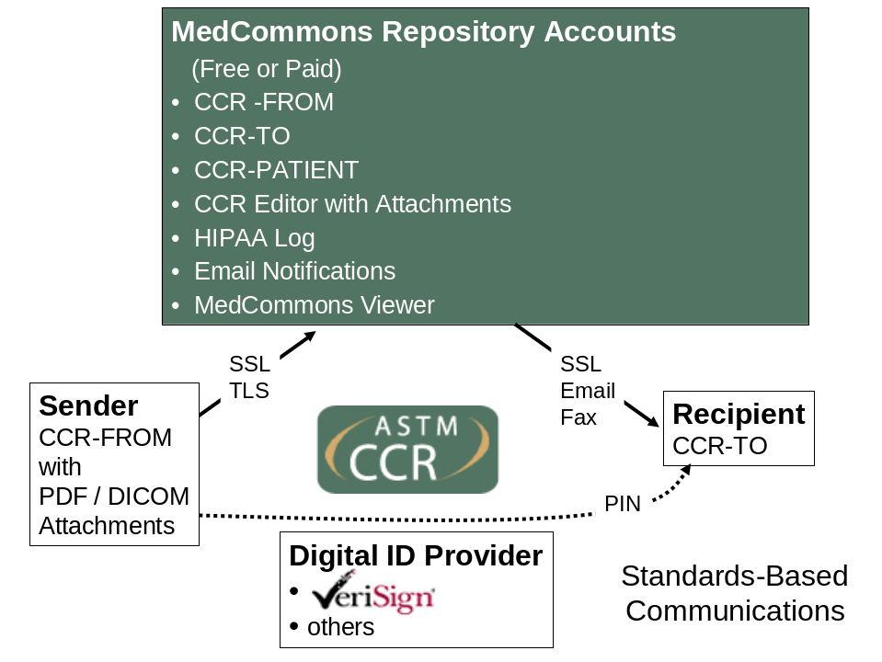

Abstract

A method is described for private and secure digital communications among health care providers and patients using standard protocols and the Internet where at least two of the principals to a transfer of protected health information (PHI) (e.g.: sender, recipient, patient) is assigned and controls a private repository. Repositories are accessed using standard protocols such as the ASTM Continuity of Care Record (CCR) and Secure HTTP (SSL). Transfers between repositories are managed by a service (MedCommons) according to consent agreements that are executed between the sender and the patient. The service also provides editing and display technology for the contents of each user’s repository and their associated security (e.g.: HIPAA) logs.

With appropriate configuration and management policies, a patient-centric network of repositories can provide private communications between any consenting parties, regardless of institutional affiliation, at very low actual cost while avoiding the hidden costs of vendor lock-in to proprietary formats and methods and without the usual risk to privacy that results from collecting and indexing massive amounts of private information in readily “mined” and very tempting registries.
Background

The vast majority of health care information technology is sold to enterprises. Patients and their physicians have traditionally had little or no influence on these purchases since managed care has traditionally been centered on the provider enterprises and insurance plans rather than the individual patient and their ability to make an informed choice.

Recent initiatives designed to align the incentives of patients and payors to make more individualized and less waateful choices include health savings accounts (HAS) for patients and pay-for-performance plans for physicians. These initiatives are most effective when they allow crossing of enterprise boundaries by patients and cross-enterprise comparisons of quality and performance and, in turn, call for interoperability and archival stability that we took for granted with paper and film medical records.

Early attempts at digital interchange of protected health information (PHI) have been based on massive regional registries of information that is mostly opaque to patients and typically expensive to access for research or public health reasons because of limited ability to seek informed consent by the patient.

Service and Technology Description


1 – The MedCommons Button will be licensed freely to CCR creators that sign (and optionally encrypt) CCRs and attached documents using the well-recognized PKI certificates (e.g. Verisign) of the patients and / or clinicians referenced in the header of the CCR – the principals.

2 – MedCommons will route, store, and replicate the CCR as necessary and notify the principals of the transfer in a manner consistent with legal privacy practice such as HIPAA and using well-known open standard protocols such as FAX, Email or RSS feed. The design of this notification will employ the principle proposed by MedCommons to IHE in 2004 and currently under consideration as the IHE Notification of Document Availability Profile.

3 – The MedCommons logo button policies, routing and notification infrastructure will operate as a Not for Profit .org with initial support from MedCommons Inc. – the .net Until the .org becomes self-sustaining and transitions to an independent board, only CCRs under 100KB total (including attached documents) will be transferred for free and store-and forward storage will be limited to 1 month. The incremental cost to MedCommons Inc. is currently estimated at 50 millicients / CCR. ($0.0005) but we expect this to decrease with time.

4 – MedCommons Inc. will operate as a for-profit public company with primary revenue from the transfer, storage and display of Personal Health Records (PHR) and diagnostic imaging studies (DICOM) attachments. MedCommons will also distribute MedCommons protocol personal and physician storage archive appliances based on OSI- compliant Free / Open Source Software (F/OSS).

5 – MedCommons.org and MedCommons Inc. will lead and support various physician and industry initiatives that promote patient privacy and medical records interoperability based on open standards and F/OSS.

Example of PHI Flow between Repositories

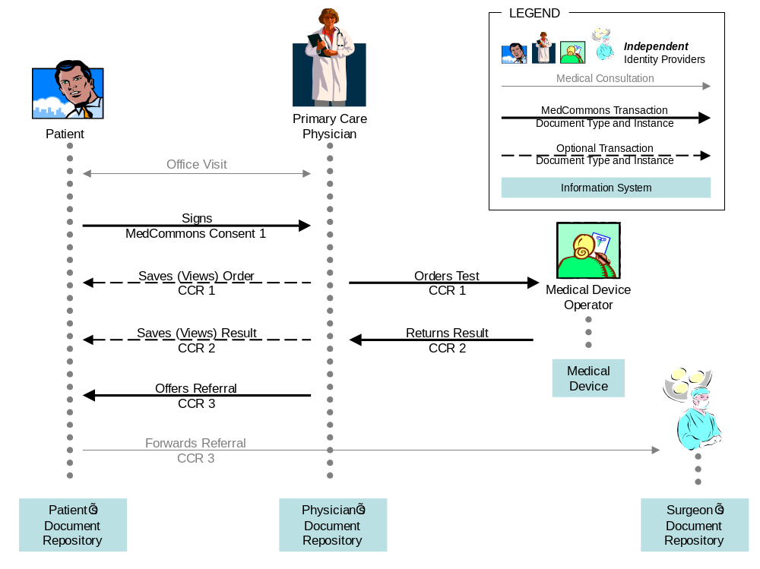

Access to personal health information (PHI) has been traditionally controlled by the enterprises that hold the data rather than the person it pertains to. Within this enterprise-centric framework, legal protections such as HIPAA force a compromise between privacy and portability. Enterprise-centric approaches commingle the identity of the people and the PHI of the patient with the enterprise information management tools thereby making interoperability across enterprise boundaries both difficult and fraught with privacy risk.
This memo describes a new method for information management based on patient control. Our approach enables the patient to voluntarily control their own identity and to associate their PHI with users they trust independent of their enterprise affiliation. Patient control facilitates interoperability across all potential recipients without artificial enterprise boundaries while providing privacy protections that meet and exceed current HIPAA mandates.
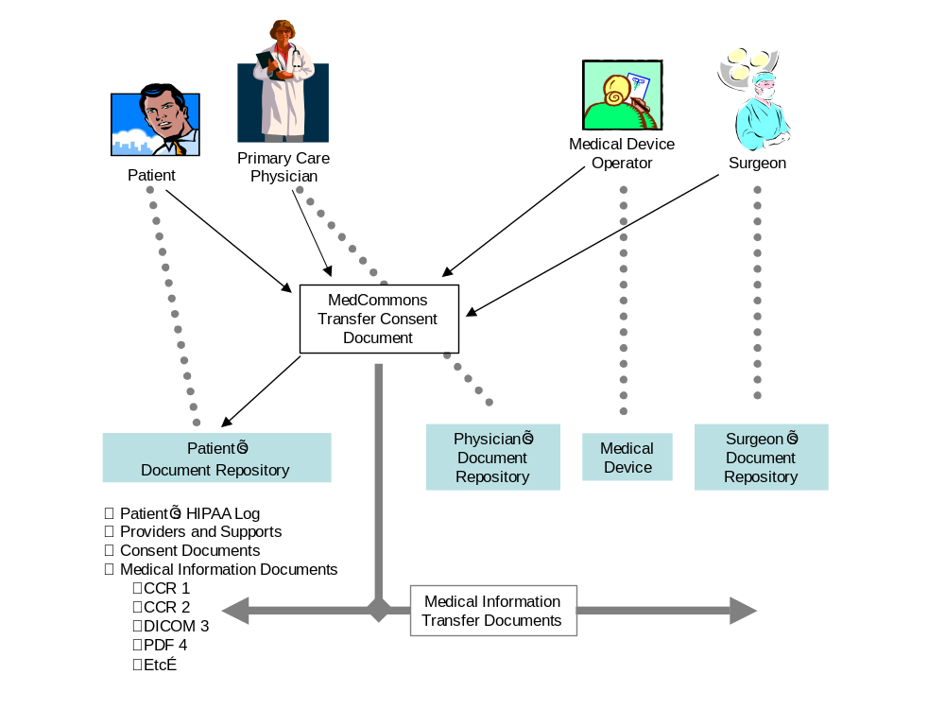
MedCommons is a service for digital transfer of PHI documents among Repositories and Medical Devices. Patients opt-in to PHI transfers by signing a Consent document which links the sender, the recipient and the patient. Consents preserve the patient’s privacy because they do not themselves expose PHI to MedCommons - in the role of registrar and transfer agent - and offer control because the clinical documents themselves as delivered to clinicians and other participants in the national information infrastructure are unmodified and provably authentic.
MedCommons innovation is the separation of user identity (as provided by a diversity of independent authorities) from the transfer agent (MedCommons) under the patient’s authority (as evidenced in the Consent document) using consent documents that do not contain PHI. The use of PHI-free Consents enables MedCommons to administer the patient’s privacy mandates as well as the more basic HIPAA legal mandates while keeping the privacy risk (and cost) of using MedCommons as transfer agent to a minimum.

Command and Control and HIPAA Log Maintenance³
Patient’s Home
Web Browser
Verisign User Cert
PDF Capture⁷
Physician’s MedCommons Repository Account¹
MedCommons SSL Cert
Physician’s
Web Browser
No cert or User Cert
PDF / DICOM Capture
[ Plugin | Extension | System Tray App ] ⁷
Surgeon’s
Repository Account¹
MedCommons SSL Cert

A1⁴
A2²
Patient’s Home
MedCommons Vault Appliance
Unencrypted Storage
Patient’s Verisign User Cert
Fixed, non-routable IP Addr.

D1⁸
D2⁹
A4⁴
Surgeon’s
MedCommons Vault Appliance
Unencrypted Storage
Surgeon’s Verisign User Cert
Fixed, non-routable IP Addr.

Surgeon’s DICOM Workstation
No Cert
A3²
C2¹⁰ DICOM
Surgeon’s
Web Browser
Verisign User Cert
or
PIN
PDF Capture⁷
C1⁸
MedCommons Central
C3⁹
Patient’s
Repository Account¹
MedCommons SSL Cert

INTERNET
B1⁴
Emails
- Notification
- Transfer activity confirmation⁶
CCR-FROM
CCR-PATIENT
CCR-TO
Verisign Level 1 CA⁵
NOTES

1. All Repository Accounts are accessed by MedCommons ID - provisional or voluntary. Each Repository Account is encrypted with its own separate key linked to the MedCommons ID. Provisional accounts are periodically purged per the Terms of Use.
2. CCR-driven Transactions typically create copies of the CCR objects and referenced attachments objects. Some repository server architectures will natively manage redundant objects on the same server or server cluster for reliability and storage efficiency.
3. All Command and Control and HIPAA Log Maintenance is accessed by Tracking Number and MedCommons ID.
4. Web browser clients are primarily connected to their user’s repository via SSL (PIN privacy) or TLS (Verisign Certificate and Consent privacy).
5. All user certificates are issued by Verisign and linked to the user’s MedCommons ID. Providers that choose to link their certificate to their HIPAA National Provider Identifier (NPI) will have the option of a logo on their Consents to allow others to know that they are voluntarily linking their reputation to their professional identity. Other than this voluntary linkage, a provider’s certificates and privileges are no different from a patient’s.
6. In lieu of transaction logs, all parties to a Consent will be notified by Email whenever a CCR / Transaction (new Tracking Number) is executed based on that Consent. Once in a user’s repository account (or vault appliance) repeated viewing / download of that CCR does not trigger repeated Emails or changes in the HIPAA Log entry status.
7. All users may install native code that performs an automatic upload of PDF or DICOM Series objects to a quarantine folder on their Repository Account. The browser Attach New Document command provisionally adds the contents of the quarantine folder to a new CCR pending user validation. For safety, only one object is allowed in the quarantine folder at a time – the most recent upload wins.
8. MedCommons Vault Appliances are open source code that maintains an unencrypted local copy of a user’s Repository Account (aka their Desktop). Vault appliances never respond to Web-based queries of any sort – not even Ping or status.
9. LAN access by a user of objects in their vault is handled as a feature of their upload plugin (Note 7). Users that do not have proper certificates to match their vault or have not installed the upload plugin into their browser can only access their vault by direct read of the vault’s disk or USB fob.
10. A DICOM workstation or PACS can be the destination of automated or user-initiated transfers from a vault appliance. As with other transfers from a vault, these transfers are invisible to MedCommons and our HIPAA Logs. The DICOM workstation or PACS hosts absolutely no MedCommons code unless the user chooses to install their vault directly on their workstation or PACS. MedCommons does not know or care about this election.
11. These four use-cases are the only use-cases included in the initial release of MedCommons. Bi-directional DICOM gateways, DICOM query proxies, enterprise portals, enterprise federation and transitive trust will be addressed in the future.
Annotated Description and Features
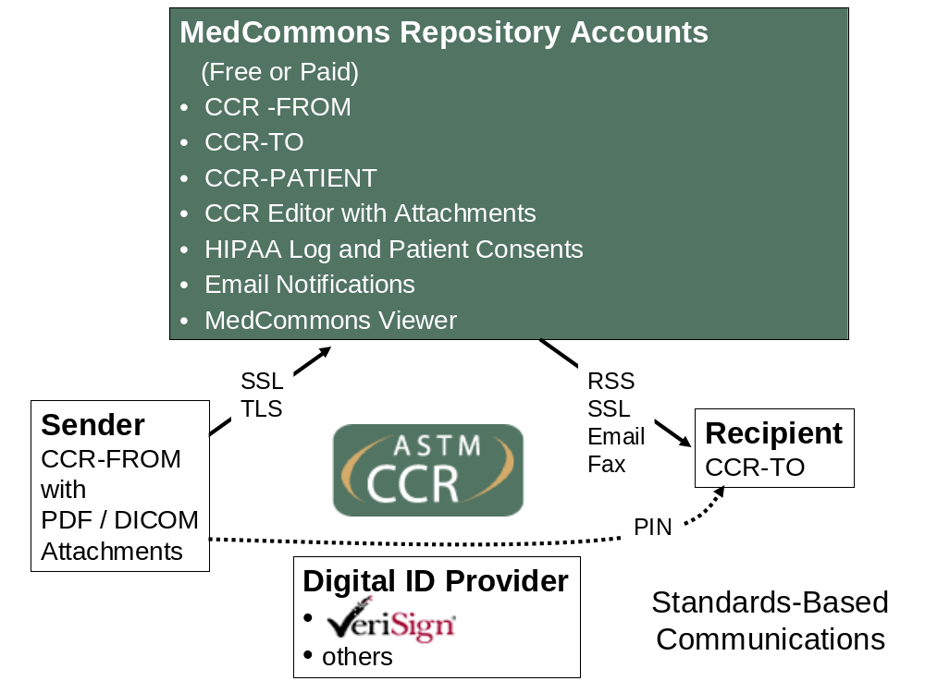
5
1
2
3
4
17
6
7
8
9
10
11
12
13
14
15
16
18
19
20
21
22
- Secured transport of standards-controlled XML (CCR) using a Registry / Repository
- Secured by independent ID service
- Secured by independent Authentication and Authorization via PIN
- Open notification via Registry pointer
- Of all participants to Consent for Audit
- Attachments to CCR
- CCR Transfer via legacy Fax with option of Web access to Attachments
- Drop box Interface with trademarked Registry Logo Button
- Repository Side-effect funds (free) temporary Registry Transport
- Repository Viewer and Interface can be Proprietary
- Client systems can be F/OSS
- Prefetch to Repository Supported by PKI Certificates
- Separate User Repositories with Shared Object Storage instead of access control (SHA-1 Hash GUIDs) to avoid unnecessary duplication
- Synchronized On-site Repositories including (USB) Token and CD /DVD-R
- Opt-in Consents indexed by Registry
- RSS feed support based on Consents as an alternative to proprietary lists
- Registry supports Health Care Proxy and Break the Glass and Federation
- Voluntary ID linked by user not database – Federal NPI linkage example for Providers
- Coded printed fax for scan and upload
- Negligible call center costs for free option
- Conversion of (VAN) portal to fixed content (CCR)
- PDF and XML Conversion

Also:
  - Objects can be readily secured because metadata Registries are Separate
  - No restrictions on use (like F/OSS) for extensibility as a platform on behalf of patients
  - Open standards protocols (WADO) for extensibility
  - Open decision on protocols in the patient interest
Description of Core Innovation

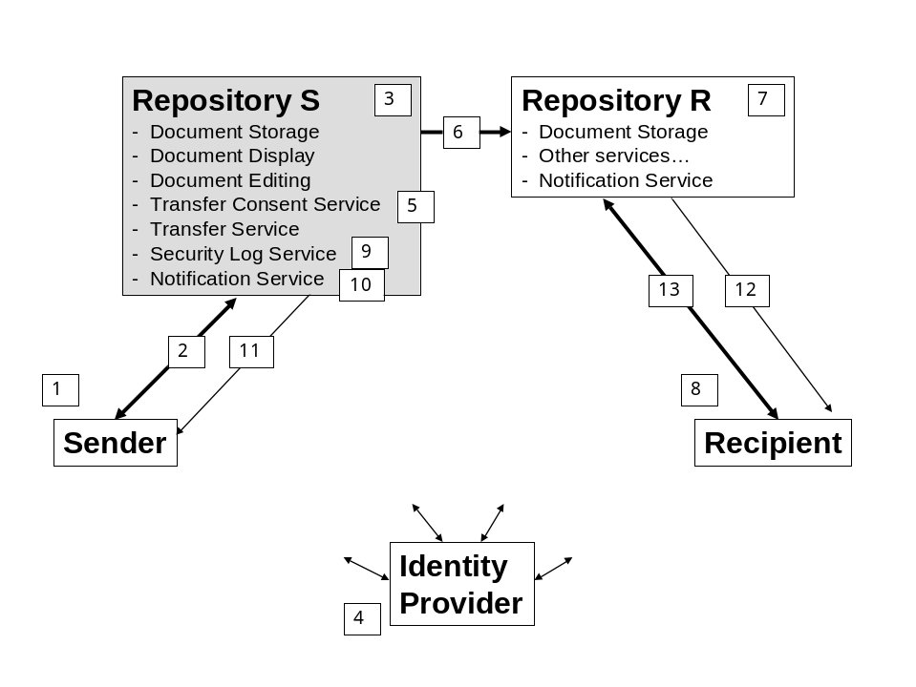
A Sender party [1] uses standards-based document formats and communications protocols [2] to place private information in Repository S [3] that they control based on information and services managed by Identity Provider [4].
Sender [1] executes a Consent agreement [5] with service provider for Repository S [3] that allows the service provider to Transfer using mutually agreed protocol [6] a copy of private information in Repository S [3] to Repository R [7] that is controlled by and accessible to Recipient [8].
Repository S [3] supports Security Log service [9] as well as a Notification Service [10] that serves alert and / or security audit functions by optionally sending messages [11] to various parties according to Consent Agreement [5] and / or the contents of private information Transfer [6]. Notifications [11] need not be private and secure as long as they use opaque (e.g.: random) pointers into their respective repository and therefore do not contain or divulge private information.
Service provider for Repository R [7] operating a Notification Service associated with their repository can send out Notification [12] to their account holder Recipient [8] which will typically be followed by the Recipient [8] accessing the private information in the Repository R [7] that they control using protocols [13].
A key benefit of this invention arises when Recipient [8] is responsible for their own private Repository [7] because this enables service provider for Repository [3] to automatically and cost-effectively fulfill their security obligations to the parties to Consent [5] as long as either Repository S [3] trusts Repository R [7] or Repository S [3] encrypts the Transfer [6] using a key accessible only to Recipient [8] such as might be provided and published by Identity Provider [4].
Although Repository S [3] can communicate with Repository R [7] using standard documents and protocols between unaffiliated parties, a further key benefit arises when Repository S [3] and Repository R [7] are operated by the same service provider or trust each other. In that case, it may be possible to avoid unnecessary duplication of some or all of the private information objects referenced in Transfer [6]. This sharing of stored objects is particularly important for diagnostic imaging studies and high resolution genetic profiles.
Finally, it bears repeating that the present invention enables everyone to communicate and interoperate with everyone else whether they trust each other’s service provider or not because formats and protocols [2] and [6] (and in the preferred embodiments [12] and [13] ) are standard (e.g.: ASTM-CCR documents with PDF and DICOM objects attached over secure HTTP) and one or more standards-compliant and typically independent Identity Provider [4] support standard attestation protocols such as SAML and federation mechanisms such as Liberty Alliance along with standard public key encryption (PKI) certificates.
Using the present invention, the Sender [1], be they a clinician or a patient, is able to communicate and interoperate with any individual or enterprise they trust by executing a Consent document with their own service provider that identifies the Recipient [8] in a mutually acceptable way including the use of a third party Identity Provider [4] or by simply communicating a shared secret (PIN) that enables access protocols [13] into Repository R [7] which in some cases will be temporarily set up as a service of the Sender’s Repository services provider. This combination of standards and a bank-like repository services provider that answers only to the Sender (who may be the patient themselves) protects the sender’s privacy because their association with their repository services provider is effectively voluntary and independent of hospitals, insurers, employers and other enterprises that may be subject to conflict-of-interest with respect to the patient’s privacy.
Privacy and Interoperability are now no longer in conflict.

